Shropshire and Wrekin Fire and Rescue Authority
Strategy and Resources Committee
20 November 2014

2015/16 and Later Years
Revenue and Capital Budgets

Report of the Treasurer
For further information about this report please contact James Walton, Treasurer, on 01743 255011, or Joanne Coadey, Head of Finance, on 01743 260215.

- Purpose of Report

This report brings together the elements of an initial revenue budget, based on the planning assumptions recommended by the Strategic Risk and Planning Group (StRaP), and seeks the Committee’s approval for this outline to be recommended to the Fire Authority in December 2014.

Recommendations

The Committee is asked to recommend that the Fire Authority:

- Notes the revisions and the committed changes to the base budget, as shown in section 4;
- Bases its pay and price contingency in the revenue budget on the calculations set out in section 5;
- Includes within its planning period:
- The schemes set out in section 6;
- The potential funding of these schemes; and
- The revenue consequences that would flow from these schemes;
- Approves changes in the planning assumptions used, when developing the budget strategy; and
- Approves the expenditure figures associated with those approved assumptions as a basis for developing the budget at the meeting of the Fire Authority on 10 December 2014.

- Background

At its meeting in February 2014, the Fire Authority approved a revenue budget of £20.725m for 2014/15, which included a budgeted surplus of £650,000. Revenue budgets to 2019/20 were also projected, along with assumed grant and precept income, which are shown below.

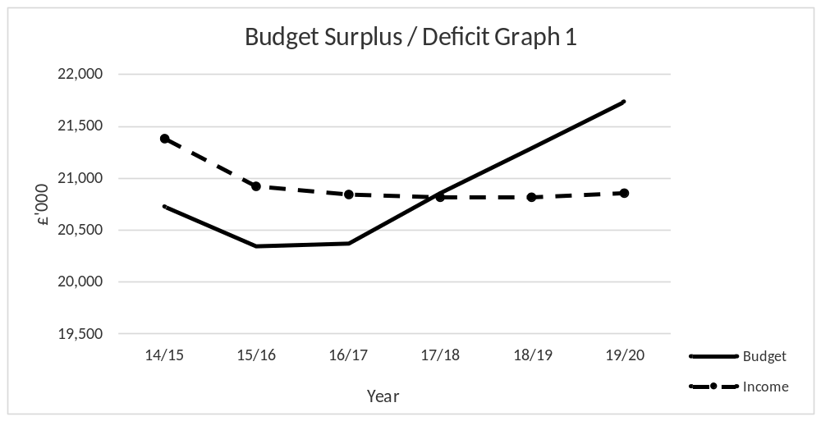

The following assumptions, upon which the budget was set, were approved by the Fire Authority:

- Precept increase of 2% from 14/15 onwards
- Pay award of 1% to 2016/17, 2% thereafter
- Revenue Support Grant reduced by 6% from 2016/17 onwards
- Council tax base growth increased from 0.4% to 0.8%
- Council tax freeze grant for 2011/12 in base from 2016/17
- Formula grant for 2014/15 and 2015/16 from Settlement in December 2013
- Business rates received from Shropshire Council and Borough of Telford & Wrekin
- Business rates top-up grant received from Government

This report deals with the revenue budget, and proposes changes in revenue expenditure. The stages in the budget process, and the proposed updates to assumptions during, and as a result of, the review are laid out in the following sections. The Committee is asked to consider each element and approve the associated recommendations at the beginning of the report.

Although funding estimates can only be completed once final information becomes available, for Council Tax Band D base and Collection Fund surpluses planning will continue, based on the assumptions adopted by the Authority.

- Stage One – Base Budget Review and Committed Changes

As the first step in the budget setting process, revenue budgets have been reviewed and considered by the Service’s Budget Management Board. This review has taken into account both changes that have been made to date to the 2014/15 revenue budget, and anticipated changes for 2015/16 and future years.

The review of the base budget has identified a number of budgets, which have not been fully utilised over the last three years. It is proposed that these budgets are reduced in 2015/16, and expenditure in these areas reviewed annually.

The Authority’s prudent approach to pay awards and inflation has meant that, as in previous years, the current contingency for pay and prices can be reduced. This follows pay awards, which have been lower than budgeted in previous years.

Capital schemes for 2015/16 and future years can be funded from revenue contributions. Therefore capital grant that has been received from central government is maintained in the balance sheet for use in future financial years.

It is recommended that a number of recommendations, approved as part of the Integrated Risk Management Planning 2020 consultation process are implemented in 2015/16. Budgeted contributions to the Earmarked Capital Reserve are not required, and revenue payments to the Pensions Account, following ill-health retirements, will now be funded from reserves.

Work on the base budget review is ongoing, and adjustments will be made throughout the budget setting process, and reported to Members.

 | 2015/16  £’000 | 2016/17  £’000 | 2017/18  £’000 | 2018/19  £’000 | 2019/20  £’000
2014/15 Budget | 20,725 | 20,725 | 20,725 | 20,725 | 20,725
Committed Changes  Firefighters’ pension revaluation  LG Pension Scheme valuation  Leasing  National Insurance changes  To be funded from base  Animal rescue training  Incident Command training | -  -  0  -20  -5 | -  -  -85  277  -277  -20  -5 | 50  40  -85  277  -277  -20  -5 | 50  40  -85  277  -277  -20  -5 | 50  40  -85  277  -277  -20  -5
Base Budget Review  Executive and Resources  Service Delivery  Corporate Governance  Buildings Maintenance  Pay Contingency  Recharges from Shropshire Fire Risk Management Services | -59  -123  -48  100  -300  -50 | -59  -123  -48  100  -300  -50 | -59  -123  -48  100  -500  -50 | -59  -123  -48  100  -500  -50 | -59  -123  -48  100  -500  -50
Revenue Contribution to Capital  Schemes from 2014/15  Capital programme | -757  1,183 | -757  - | -757  - | -757  - | -757  -
2020 Outcomes  Capital reserve contributions  Ill-health retirement contributions | -100  -200 | -100  -200 | -100  -200 | -100  -200 | -100  -200
Total | 20,346 | 19,078 | 18,968 | 18,968 | 18,968
Total movement in  base budget | -379 | -1,647 | -1,757 | -1,757 | -1,757

Please see recommendation a).

- Stage Two – Pay and Price Contingency

Officers have used the following methodology for establishing pay and prices contingencies:

- Analyse base budget (2014/15) into the spending areas, where pay or price changes can be significant;
- Make pay assumptions for firefighters, based on a realistic expectation for the outcome of the nationally negotiated settlement;
- Make pay assumptions for other pay, based on a realistic expectation of the outcome of any outstanding negotiations;
- Take account of known issues, such as increments; Continuing Professional Development, National Insurance and tax changes; and
- Analyse the non-pay and income budgets into key elements, including those to which no inflation applies, and create an appropriate contingency.

Current Developments

During 2011/12, the Government announced a pay cap of 1% from 2013/14 for two years, with a corresponding reduction in formula grant. As a result, contingencies for pay in the revenue budget were held at 1% in 2014/15.

Officers have reviewed the assumptions on future pay and price contingencies, and have held estimates for 2015/16 and 2016/17 at 1%. However, an increase to 2% is assumed for each year thereafter, to reflect possible improvements in the economic outlook.

Pay awards for support staff are currently being negotiated, and may be settled in excess of 1%. The final settlement will be covered within the proposed contingency.
In terms of prices, inflation assumptions have been held at 2.5%, however the base, upon which the contingency is calculated, has been reduced, in line with usage in previous years.

Conclusions

It is proposed that the figures for pay and price assumptions over the planning period will be budgeted as follows:

 |  | Pay |  | Prices
 | % | £’000 | % |  | £’000
2015/16 | 1.0 | 138 | 2.5 |  | 80
2016/17 | 1.0 | 139 | 2.5 |  | 82
2017/18 | 2.0 | 252 | 2.5 |  | 84
2018/19 | 2.0 | 286 | 2.5 |  | 86
2019/20 | 2.0 | 292 | 2.5 |  | 88

Please see recommendation b).

- Stage Three – Capital Programme 2015/16 to 2019/20

The Authority has already agreed capital programmes for 2014/15 and earlier years. It has also agreed how these schemes are funded and the revenue consequences for future years.

This stage deals with the options available for new schemes, starting next year.

The Capital Programme from 2015/16

The schemes currently under consideration include appliances and operation equipment, and are set out in the appendix to this report, and can be summarised as follows:

Year of Start |  | Total Project Cost of Starts |  | Revenue Consequences
Year of Start |  | £ 000 |  | 2015/16  £ 000 |  | 2016/17  £ 000 |  | 2017/18  £ 000 |  | 2018/19  £ 000 |  | 2019/20  £000
2015/16 |  | 910 |  |  |  | 10 |  | 10 |  | 10 |  | 10
2016/17 |  | 25 |  |  |  |  |  | 5 |  | 5 |  | 5
2017/18 |  | 25 |  |  |  |  |  |  |  | 5 |  | 5
2018/19 |  | 25 |  |  |  |  |  |  |  |  |  | 5
2019/20
 |  | 1,010 |  | 5 |  | 15 |  | 20 |  | 25 |  | 30
Annual Addition |  |  |  | 5 |  | 10 |  | 5 |  | 5 |  | 5

The capital programme will be reviewed and completed by officers and brought to the Committee in January.

It should be noted that revenue consequences are limited to financing costs – any other costs need to be flagged up as part of the project appraisals. Also, the Authority is presently only committing itself to schemes that start in 2015/16. The majority of schemes are currently shown as being spent in the start year. However, experience shows that payments often slip into later years, thereby slowing the build-up of costs and resulting in revenue underspendings.

Currently, where schemes are to be funded from the Earmarked Capital Reserve, repayments are made back into the reserve to ensure that funds are available for future replacements. However, if it is agreed in recommendation a) that revenue contributions will no longer be made to the Reserve for new capital schemes, these can be removed.

Appraisals for each scheme will confirm their service value, the capital cost, phasing of expenditure and revenue consequences. There is, therefore, scope for these figures to change, especially if there are any associated revenue consequences, such as running costs of property or systems.

Prudential Guidelines

In addition to the merits of the individual schemes within the final capital programme presented in January, the Authority will need to evaluate the programme in the light of Prudential and Treasury Management Guidelines. Compliance with these indicators will demonstrate the affordability, sustainability and prudence of the proposed programme of schemes.

Future Capital Schemes

The forward capital programme is being thoroughly reviewed by officers and any future requests for schemes will be considered as part of the ongoing strategic planning process. Projects for consideration will be tested to ensure that, as far as possible, they are both realistically costed and resourced; will start when scheduled; and that, where possible, they have long-term revenue saving potential.

Please see recommendation c).

- Revised Budget Summary

The changes to revenue expenditure, covered in the previous sections, can be summarised as follows:

 | 2015/16 | 2016/17 | 2017/18 | 2018/19 | 2019/20
 | £000 | £000 | £000 | £000 | £000
Previous Year’s Budget | 20,725 | 20,574 | 19,532 | 19,763 | 20,140
Committed Change | -379 | -1,268 | -110 | - | -
Pay and Prices | 218 | 221 | 336 | 372 | 380
2015/16 and later Capital Programme | 10 | 5 | 5 | 5 | 5
 | 20,574 | 19,532 | 19,763 | 20,140 | 20,525
- Funding Assumptions

Officers have continued to use the Service’s budget planning model, which is estimating budgets and income to 2019/20. Financial planning will forecast the position of the revenue budget to 2019/20, but with emphasis on the medium term, i.e. 2015/16 to 2017/18.

Forecasts for the longer term are provided within the table on page 9 as an indication of the financial position, based on a number of uncertain assumptions. Officers and Members should note this longer-term position and have plans and options available to meet a range of possible outcomes.

Work undertaken to date indicates that the Authority’s budget planning strategy is on target, following the Public Value process, which reduced the revenue budget by around £3million. Revenue surpluses, which accumulated following the process, have been used to fund capital schemes, therefore maintaining stable capital reserves. Resources have also been allocated to the Service Transformation Programme, to enable essential improvement schemes to be completed.

The current financial position of the Authority has presented a number opportunities for Members’ consideration. The review of the base budget has resulted in further reductions in expenditure, and a precept increase of more than 1% in 2015/16 is not, therefore, required. It was announced as part of last year’s settlement that a freeze grant equivalent to a precept increase of 1% is available to those authorities that freeze council tax, and that this grant would be built into the base settlement. As a result the Authority could fund its budget requirement with no impact on the public of Shropshire.

In terms of medium-term planning, precept increases of 1% would continue to fund the Authority’s budget requirement. Precept increases above this level should be considered, if further contributions to reserves were required, but this is not currently a priority for the Service. The position would be reviewed as each revenue budget is set over the planning period.

The possible longer-term position of the Authority’s revenue budget should not be overlooked. With further reductions in grant expected over the next five years, and inflationary pressures on existing expenditure, Members should consider how an increasing revenue budget will be funded from reducing income. The Authority’s Integrated Risk Management Planning 2020 consultation process has ensured that the Service has plans in place to reshape service delivery into 2019/20 and beyond the current planning period.

Strategic Risk and Planning Group (StRaP)

A meeting of StRaP was held on 4 November, when the assumptions approved by the Fire Authority, as part of the 2014/15 budget process, were presented. Work undertaken by officers, based on current economic and budget forecasts, resulted in changes to these assumptions, to be considered by the Group. Members considered these changes, and the Group’s preferences are shown in bold italics in the table on the following page.

Area | Assumptions approved for 2014/15 budget | Proposed changes to assumptions for 2015/16 onwards
Grant reduction | Reductions for 2014/15 as per grant settlement  6% reduction per year projected from 2016/17 | Reductions for 2015/16 as per grant settlement  8% reduction per year projected from 2016/17
Freeze Grant | 2011/12 - grant rolled into settlement  2015/16 - grant equivalent to 1% precept available, rolled into base, not to be accepted | 2011/12 - grant rolled into settlement  2015/16 - grant equivalent to 1% precept available, rolled into base, to be accepted
Precept | 2% precept increase from 2015/16 onwards | Nil increase for 2015/16 – accept freeze grant of 1%  1% increase for 2016/17 and 2017/18  2% increase for 2018/19 onwards

The following observations were made.

- Although future underspends in revenue, budgeted surpluses and further increases in precept income would contribute further to reserves, increasing precept by 2% in 2015/16 should be the priority in financial planning, and the freeze grant should not be accepted.

- Future precept increases of 2% should be continued over the next five years, in order to safeguard the Service into the future.

- The public of Shropshire have stated that increases in fire precept are supported.

- It is prudent to increase future grant reductions to 8%.

- If the referendum limit were removed, the Authority would be more able to increase precept, when required.

- Government ministers should be lobbied about the removal of the referendum limit, as opposed to further levels of grant reduction.

- Shropshire MPs should be made aware of the process, prior to the budget being set in February 2015.

The table on the following page exemplifies the assumptions recommended by officers, and those favoured by StRaP.

 | Surplus / -Deficit on revenue budget
 | 2015/16  £000 | 2016/17  £000 | 2017/18  £000 | 2018/19  £000 | 2019/20  £000
Proposed assumptions:  8% grant reduction from 2016/17  Nil increase in precept 2015/16, 1% 2016/17, 2017/18, 2% thereafter | 228 | 899 | 350 | -158 | -622
StRaP preferred assumptions:  8% grant reduction from 2016/17  2% increase in precept 2015/16 and thereafter | 362 | 1,203 | 814 | 329 | -108

The Committee is asked to consider the assumptions contained within the report, and their effect on the planning model figures provided, and make recommendations to the meeting of the Fire Authority in December about the basis, upon which its financial planning should progress.

- Financial Implications

The financial implications are as outlined in the main body of the report.

- Legal Comment

There are no direct legal implications arising from this report.

- Initial Impact Assessment

An Initial Impact Assessment has been completed for this report.

- Appendices

There are no appendices attached to this report.

- Background Papers

There are no background papers associated with this report.

