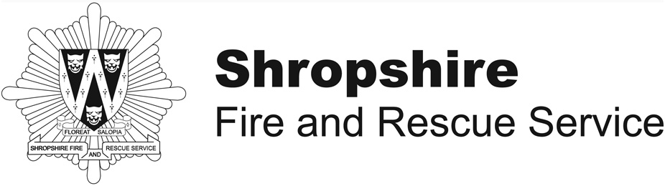 | Fire Risk Assessment

1 Premises Details

Premises Name

Address

Contact Telephone Number

Use of Premises
Name of Responsible Person/Owner/Employer/Person in Control of Workplace
Single or more than one occupier in the premises | Single ◻ Multiple Occupiers ◻
If there is more than one occupier, have you discussed the fire safety arrangements for the building together? | Yes ◻ No ◻

Date assessment conducted
Name and details of person conducting assessment
Review date for assessment

2 Fire Safety Policy Statement

Statement:

‘It is the policy of …………………..……………… to protect all persons including
employees, visitors, contractors and members of the public from potential
injury and damage to their health which might arise from work activities.
We will provide and maintain safe working conditions, equipment and systems
of work for all employees, and to provide such information, training and
supervision as they need for this purpose’.

Signed: …………………………………………………… Date: ……………………………
(Print name) ………………………………………………

3 General Description Of The Premises

Give a general description of the premises and the use to which it is put.
Hours of the day and days of the week the premises is used.

Total number of persons present in the premises at any one time
Hours of the day and days of the week the premises is used and by how many

 | Monday | Tuesday | Wednesday | Thursday | Friday | Saturday | Sunday
0000 - 0400
0400 - 0800
0800 - 1200
1200 - 1600
1600 - 2000
2000 - 2400

Size of the premises in square metres

Number of floors?

How many basement or cellar levels?

How many floors do you occupy?

Construction of building e.g. brick built, tiled pitch roof

4 Plan Drawing
Factories and Warehouses Guide Page 34
A plan could be drawn and/or a description of the premises to show the layout of the building and the location of any general fire precautions and fire exits.

5 Identify Fire Hazards

Sources of Ignition
Electrical equipment and installations, naked flame, work processes
Factories and Warehouses Guide Page 12

Sources of Fuel
Combustibles, cardboard, furnishings, wall coverings, highly flammable/dangerous substances
Factories and Warehouses Guide Page 13

Work Processes
Hot work, welding, soldering, chemical processes, cooking
Factories and Warehouses Guide Page 41-44

Structural features that could promote the spread of fire
Voids and cavities in roof spaces and wall cavities
Factories and Warehouses Guide Page 49-53 and 67

6 Control Measures

What control measures are in to place to reduce the likelihood of a fire and to reduce the spread of fire?

E.g. reduce amount of cardboard stored in premises, separate combustible materials from ignition sources, change work processes for safer ways of working, look at installing cavity barriers and fire doors

Factories and Warehouses Guide Page 42-49

Are any additional measures considered necessary?

7 Identify People at Risk
Identify and specify the location of people at significant risk in case of fire, indicating why they are at risk, and what control’s are or need to be in place

i.e. Lone workers, disabled, children and young persons, occupancy numbers

Factories and Warehouses Guide Page 14, 54 and 68

8 Fire fighting and Fire Detection
Factories and Warehouses Guide Page 21-23 and 55-65

 | What are your current  arrangements? | Actions Required
What fire fighting equipment do you have in place and is it sufficient and located correctly?
What measures do you have in place to ensure sufficient staff are trained in use of fire fighting equipment?
What are the measures you have in place for giving warning, including the use of automatic fire detection systems?
What signage do you have in place for the fire/detection system?
What measures are in place to ensure your employees are trained on how to operate the fire alarm/detection system and what action they should take upon hearing it?
What measures are in place to ensure the fire routine notices are clearly displayed throughout the premises?

9 Emergency Routes and Exits
Factories and Warehouses Guide Page 24-31 and 66-109

 | What are your current arrangements? | Action Required
What measures are in place to ensure that everyone can safely escape from the premises?
What measures are in place to ensure that all the exit routes and exits are signed?
What measures are in place to ensure that all exit routes are illuminated?
What measures are in place to ensure that all staff has been trained in evacuation procedures?

Please refer to the Department for Communities and Local Government Fire Safety Guides which can be found on the following website www.communities.gov.uk and are free to download in PDF format. Hard copies of the guides can be purchased.

10 Method for Calling the Fire Service

Name or role of the person responsible for contacting the fire service in the event of a fire or emergency

11 Actions to be taken in the event of a fire or emergency

Raising the alarm, evacuation procedures, shutdown procedures, contacting fire service etc.
Factories and Warehouses Guide Page 35

12 Training

Details of training given which should take into account the actions identified in your emergency plan. Training should be given to all staff including temporary, casual and part time staff.
Factories and Warehouses Guide Page 37-38 and 115-117

13 Arson Policy

What arrangements do you have in place to reduce the risk from arson?

Do you have regular waste removal; do you secure your premises when empty?
Factories and Warehouses Guide Page 53

14 Risk Reduction Plan
Factories and Warehouses Guide Page 33

What do you need to do next to make sure that you are compliant with the Regulatory Reform (Fire Safety) Order 2005 and when you will complete them?

Action Required – Copied from above sections | Priority  Low/Med/High | Actioned By | Date

15 Additional Notes or Information

